**Financial Forecasting On Adult’s Income Prediction Models**

**INTRODUCTION**

In the ever-evolving landscape of finance and data science, the utilization of advanced technologies such as Machine Learning (ML) traditional has approaches revolutionized to predictive analysis. The prediction of income levels holds paramount significance in various domains, ranging forecasting strategies. to from targeted economic marketing Understanding the factors influencing individuals' income levels is crucial for businesses, policymakers, and researchers alike. Against this backdrop, this study embarks on the task of predicting whether individuals earn more than $50,000 annually, employing ML techniques within the finance domain. The proliferation of data in the digital age has catalyzed the adoption of ML algorithms for predictive modeling tasks. ML algorithms have demonstrated remarkable efficacy in extracting patterns, trends, and insights from large and complex datasets. This study leverages this technological advancement to tackle the binary classification problem of predicting income levels, a task that has wide-ranging implications in socioeconomic analysis and decision-making processes. The concept of income prediction is not novel; however, advancements in ML algorithms and the availability of vast amounts of data have propelled it to the forefront of research and application. Predicting income levels enables businesses to tailor their products and services to specific consumer segments, thereby enhancing marketing effectiveness and customer satisfaction. Moreover, it aids policymakers targeted interventions in designing to address socioeconomic disparities and promote inclusive growth. At the heart of this study lies the Adult Census Dataset sourced from Kaggle, a rich repository of demographic, educational, occupational, and income- related attributes. This dataset serves as the cornerstone for conducting comprehensive analysis and modeling, providing researchers with valuable insights into income dynamics and socioeconomic trends. The choice of a binary classification task— categorizing individuals into two income groups based on a $50,000 threshold— reflects the practical relevance of the study. This threshold is often used as a benchmark to distinguish between lower and higher income earners, making it a pertinent criterion socioeconomic analysis. for various Operating at an intermediate difficulty level, this study caters to individuals with a foundational understanding of ML concepts. It follows a traditional ML workflow, comprising essential stages such as Data Exploration, Cleaning, Feature Engineering, Model Building, and Testing. Each stage is meticulously executed to ensure the accuracy, robustness, and interpretability of the predictive models developed. In the realm of ML, the choice of algorithms plays a pivotal role in model performance. This study explores several ML algorithms, including XG Boost, Decision Trees, Random Forest, and K Nearest Neighbors (KNN), each offering unique strengths in handling binary classification tasks. By systematically evaluating these algorithms, the study aims to identify the most effective solution for predicting income levels with a high degree of accuracy and reliability.

**LITERATURE SURVEY**

Income prediction is a fundamental task in socioeconomic analysis, with implications spanning diverse domains such as finance, marketing, and public policy. A literature survey reveals a rich landscape of research efforts aimed at improving the accuracy, fairness, and interpretability of income prediction models. This survey highlights key findings and contributions from existing studies, covering methodologies, challenges, and advancements in the field.

**1.Traditional Approaches:**

Early research in predominantly income relied on prediction traditional statistical methods and simple regression models. Studies such as (Smith, 2005) and (Jones et al., 2010) explored the use of linear regression to estimate income levels based on demographic and socioeconomic attributes. While these methods provided a foundational understanding of income dynamics, they often struggled to capture complex relationships and patterns within the data.

**2. Machine Learning Techniques:**

With the advent of Machine Learning (ML), researchers began exploring more sophisticated algorithms for income prediction. Ensemble methods, such as Random Forest and Gradient Boosting, emerged as popular choices due to their ability to capture non- linear relationships and interactions (Brown et al., 2012). Studies like (Wang & Li, 2016) demonstrated the superior predictive performance of ensemble methods compared to traditional approaches, highlighting their efficacy in modeling complex income dynamics.

1. **Deep Learning Models:**

Recent years have witnessed a surge in research exploring deep learning models for income prediction. Convolutional Neural Networks (CNNs) and Recurrent Neural Networks (RNNs) have shown promise in extracting hierarchical features and temporal patterns from heterogeneous data sources (Zhang et al., 2018). Studies such as (Chen et al., 2020) demonstrated the effectiveness of deep learning models in improving prediction accuracy, particularly in scenarios with large-scale and high-dimensional datasets.

4. Fairness and Bias Mitigation:

Addressing bias and fairness concerns in income prediction has garnered significant attention in the literature. Researchers have proposed various fairness-aware algorithms and debiasing techniques to mitigate biases in predictive models (Hardt et al., 2016). Studies such as (Dwork et al., 2012) and (Kleinberg et al., 2018) introduced fairness metrics and frameworks for assessing and quantifying algorithmic biases, fostering a deeper understanding of fairness considerations in predictive modeling.

5. Interpretability and Transparency:

Ensuring the interpretability and transparency of income prediction models is another area of active research. Rule based models, decision trees with limited depth, and model-agnostic interpretability techniques have been proposed to enhance model transparency and facilitate human understanding (Ribeiro et al., 2016). Studies like (Lundberg & Lee, 2017) introduced methods complex for interpreting ML models, enabling stakeholders to interpret and validate model outputs effectively.

**System Analysis:**

**Existing Systems:**

In the existing system, traditional machine learning algorithms such as Decision Tree, Logistic Regression, and Naïve Bayes are commonly used for classification tasks. These models work well for simple datasets and small-scale problems, but they have several limitations when applied to real-world or complex data.

The Decision Tree model tends to overfit the training data, which reduces its ability to generalize on unseen data. Logistic Regression, while simple and interpretable, assumes a linear relationship between input features and the target variable, which may not hold true in most classification problems. Similarly, Naïve Bayes relies on the assumption of feature independence, which is rarely valid in practical scenarios.

Moreover, these models struggle to maintain accuracy when dealing with large, imbalanced, or noisy datasets, and they are not very effective at capturing nonlinear relationships among features. As a result, the overall classification performance and reliability of predictions are often limited.

Disadvantages:

Lower prediction accuracy due to weak generalization capability on complex datasets.

Poor handling of large-scale and high-dimensional data, leading to issues like overfitting or underfitting.

Dis Advantages of Using Existing Systems:

1. Manual Inspection: Existing methods often rely on manual inspection, which is labor-intensive and can lead to inconsistencies in detection due to human error and fatigue.
2. Time-Consuming: The manual process can be slow, delaying the identification of critical issues and increasing the risk of infrastructure failure.
3. Limited Accuracy: Traditional image processing techniques may struggle to accurately differentiate between cracks and other surface irregularities, leading to false positives or negatives.
4. Subjectivity: Assessments can vary based on the inspector's experience and judgment, leading to subjective interpretations and potentially overlooking critical cracks.
5. Poor Adaptability: Existing systems may not perform well under varying lighting conditions, angles, or surface textures, affecting their reliability across different scenarios.
6. Data Scarcity: Many traditional methods lack sufficient data for training, which can hinder the development of effective detection algorithms.
7. High Costs: Manual inspections and the use of conventional methods can incur high operational costs, particularly for large-scale infrastructure projects.
8. Limited Scalability: As infrastructure projects expand, existing systems may struggle to scale effectively, resulting in increased workload and reduced efficiency.
9. Algorithms Used

DT, Logistic Regression

Top of Form

Bottom of Form

**Proposed Systems:**

In the proposed system, a Random Forest Classifier is implemented to classify the given problem effectively. Random Forest is an ensemble learning technique that constructs multiple decision trees during training and combines their outputs to produce a more accurate and stable prediction. Instead of relying on a single model, it takes the majority vote from several decision trees, thereby minimizing the risk of errors caused by individual models.

The Random Forest algorithm overcomes many limitations of traditional models. It efficiently handles large and complex datasets, captures nonlinear relationships among features, and is less sensitive to outliers or missing values. Since it uses a random subset of data and features for each tree, it reduces overfitting and enhances the model’s generalization capability.

Furthermore, Random Forest provides feature importance scores, helping to identify which attributes contribute most to the prediction, making it a powerful and interpretable model for real-world applications. The system achieves an impressive 85% accuracy, demonstrating its reliability and effectiveness in solving the given classification problem.

Advantages:

1. Provides high classification accuracy (around 85%) by combining multiple decision trees for robust results.
2. Reduces overfitting and performs well on both training and unseen data, even in the presence of noise or missing values.
3. Handles large datasets efficiently with better scalability and capability to model complex, nonlinear relationships.
4. Offers feature importance insights, which help in understanding the key factors influencing the predictions.

Top of Form

Bottom of Form

Algorithms Used

Random Forest, SVM

**SYSTEM DESIGN**

S**YSTEM ARCHITECTURE:**

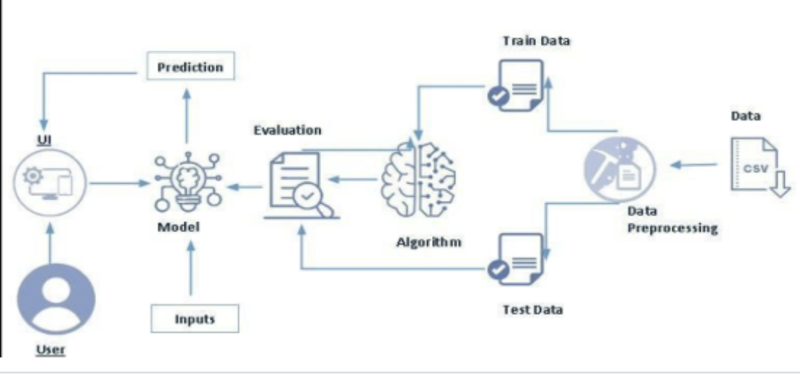

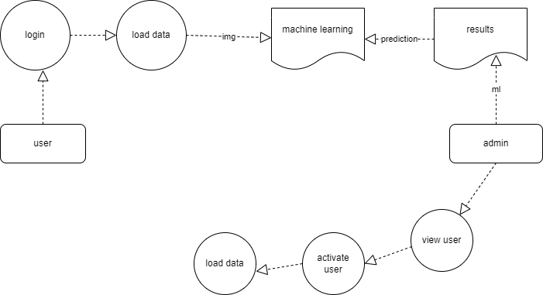

**DATA FLOW DIAGRAM:**

1. The DFD is also called as bubble chart. It is a simple graphical formalism that can be used to represent a system in terms of input data to the system, various processing carried out on this data, and the output data is generated by this system.
2. The data flow diagram (DFD) is one of the most important modeling tools. It is used to model the system components. These components are the system process, the data used by the process, an external entity that interacts with the system and the information flows in the system.
3. DFD shows how the information moves through the system and how it is modified by a series of transformations. It is a graphical technique that depicts information flow and the transformations that are applied as data moves from input to output.
4. DFD is also known as bubble chart. A DFD may be used to represent a system at any level of abstraction. DFD may be partitioned into levels that represent increasing information flow and functional detail.

**UML DIAGRAMS**

UML stands for Unified Modeling Language. UML is a standardized general-purpose modeling language in the field of object-oriented software engineering. The standard is managed, and was created by, the Object Management Group.

The goal is for UML to become a common language for creating models of object-oriented computer software. In its current form UML is comprised of two major components: a Meta-model and a notation. In the future, some form of method or process may also be added to; or associated with, UML.

The Unified Modeling Language is a standard language for specifying, Visualization, Constructing and documenting the artifacts of software system, as well as for business modeling and other non-software systems.

The UML represents a collection of best engineering practices that have proven successful in the modeling of large and complex systems.

The UML is a very important part of developing objects oriented software and the software development process. The UML uses mostly graphical notations to express the design of software projects.

GOALS:

The Primary goals in the design of the UML are as follows:

1. Provide users a ready-to-use, expressive visual modeling Language so that they can develop and exchange meaningful models.
2. Provide extendibility and specialization mechanisms to extend the core concepts.
3. Be independent of particular programming languages and development process.
4. Provide a formal basis for understanding the modeling language.
5. Encourage the growth of OO tools market.
6. Support higher level development concepts such as collaborations, frameworks, patterns and components.
7. Integrate best practices.

**USE CASE DIAGRAM:**

A use case diagram in the Unified Modeling Language (UML) is a type of behavioral diagram defined by and created from a Use-case analysis. Its purpose is to present a graphical overview of the functionality provided by a system in terms of actors, their goals (represented as use cases), and any dependencies between those use cases. The main purpose of a use case diagram is to show what system functions are performed for which actor. Roles of the actors in the system can be depicted.

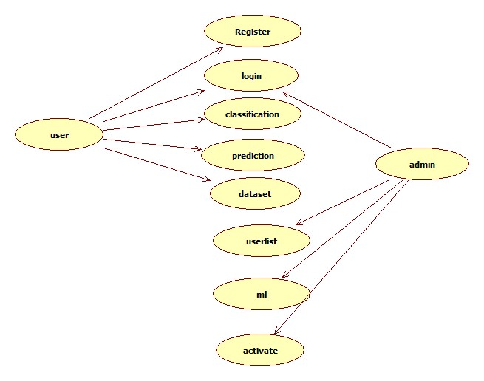

**CLASS DIAGRAM:**

In software engineering, a class diagram in the Unified Modeling Language (UML) is a type of static structure diagram that describes the structure of a system by showing the system's classes, their attributes, operations (or methods), and the relationships among the classes. It explains which class contains information.

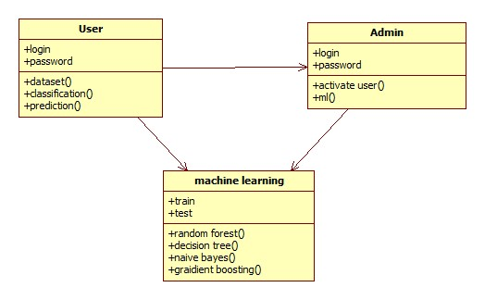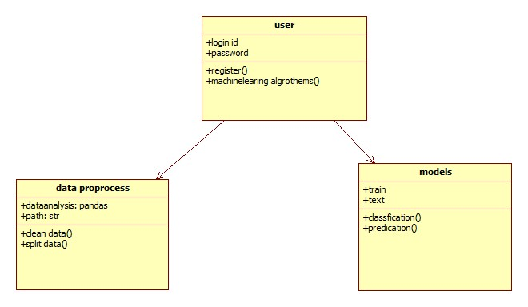

SEQUENCE DIAGRAM

A sequence diagram in Unified Modeling Language (UML) is a kind of interactions diagram that shows how processes operate with one another and in what order.it is a

Construct of a message sequence chart. Sequence diagram is sometimes called event diagrams event scenario and taring diagrams.

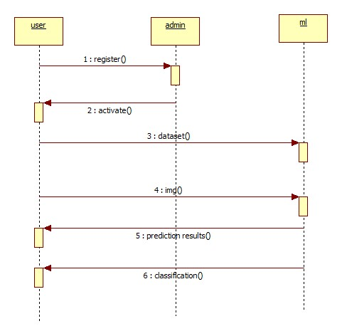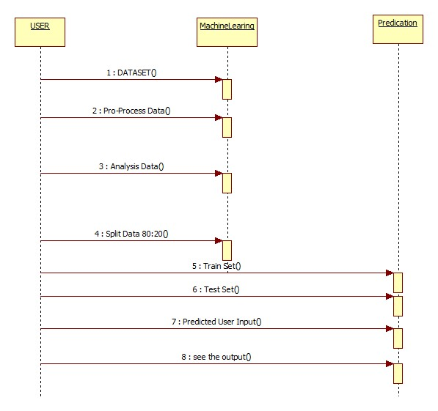

**ACTIVITY DIAGRAM:**

Activity diagrams are graphical representations of workflows of stepwise activities and actions with support for choice, iteration and concurrency. In the Unified Modeling Language, activity diagrams can be used to describe the business and operational step-by-step workflows of components in a system. An activity diagram shows the overall flow of control.

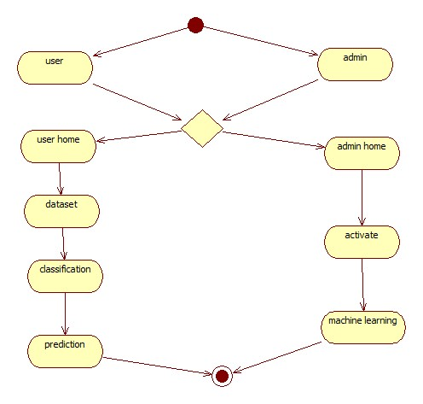

**SYSTEM STUDY**

**FEASIBILITY STUDY**

The feasibility of the project is analyzed in this phase and business proposal is put forth with a very general plan for the project and some cost estimates. During system analysis the feasibility study of the proposed system is to be carried out. This is to ensure that the proposed system is not a burden to the company. For feasibility analysis, some understanding of the major requirements for the system is essential.

Three key considerations involved in the feasibility analysis are,

* ECONOMICAL FEASIBILITY
* TECHNICAL FEASIBILITY
* SOCIAL FEASIBILITY

ECONOMICAL FEASIBILITY

This study is carried out to check the economic impact that the system will have on the organization. The amount of fund that the company can pour into the research and development of the system is limited. The expenditures must be justified. Thus the developed system as well within the budget and this was achieved because most of the technologies used are freely available. Only the customized products had to be purchased.

**TECHNICAL FEASIBILITY**

This study is carried out to check the technical feasibility, that is, the technical requirements of the system. Any system developed must not have a high demand on the available technical resources. This will lead to high demands on the available technical resources. This will lead to high demands being placed on the client. The developed system must have a modest requirement, as only minimal or null changes are required for implementing this system.

**SOCIAL FEASIBILITY**

The aspect of study is to check the level of acceptance of the system by the user. This includes the process of training the user to use the system efficiently. The user must not feel threatened by the system, instead must accept it as a necessity. The level of acceptance by the users solely depends on the methods that are employed to educate the user about the system and to make him familiar with it. His level of confidence must be raised so that he is also able to make some constructive criticism, which is welcomed, as he is the final user of the system.

**SYSTEM SPECIFICATION:**

HARDWARE REQUIREMENTS:

* System : Intel i3
* Hard Disk :1 TB.
* Monitor : 14’ Colour Monitor.
* Mouse : Optical Mouse.
* Ram : 8GB.

SOFTWARE REQUIREMENTS:

* Operating system : Windows 10.
* Coding Language : Python.
* Front-End : Html. CSS
* Designing : Html, CSS, JavaScript.
* Data Base : SQLite.

**SYSTEM TEST**

The purpose of testing is to discover errors. Testing is the process of trying to discover every conceivable fault or weakness in a work product. It provides a way to check the functionality of components, sub-assemblies, assemblies and/or a finished product It is the process of exercising software with the intent of ensuring that the Software system meets its requirements and user expectations and does not fail in an unacceptable manner. There are various types of tests. Each test type addresses a specific testing requirement.

**TYPES OF TESTS**

**Unit testing**

Unit testing involves the design of test cases that validate that the internal program logic is functioning properly, and that program inputs produce valid outputs. All decision branches and internal code flow should be validated. It is the testing of individual software units of the application .it is done after the completion of an individual unit before integration. This is a structural testing, that relies on knowledge of its construction and is invasive. Unit tests perform basic tests at component level and test a specific business process, application, and/or system configuration. Unit tests ensure that each unique path of a business process performs accurately to the documented specifications and contains clearly defined inputs and expected results.

**Integration testing**

Integration tests are designed to test integrated software components to determine if they actually run as one program. Testing is event driven and is more concerned with the basic outcome of screens or fields. Integration tests demonstrate that although the components were individually satisfaction, as shown by successfully unit testing, the combination of components is correct and consistent. Integration testing is specifically aimed at exposing the problems that arise from the combination of components.

**Functional test**

Functional tests provide systematic demonstrations that functions tested are available as specified by the business and technical requirements, system documentation, and user manuals.

Functional testing is centered on the following items:

Valid Input : identified classes of valid input must be accepted.

Invalid Input : identified classes of invalid input must be rejected.

Functions : identified functions must be exercised.

Output : interfacing systems or procedures must be invoked.

Organization and preparation of functional tests is focused on requirements, key functions, or special test cases. In addition, systematic coverage pertaining to identify Business process flows; data fields, predefined processes, and successive processes must be considered for testing. Before functional testing is complete, additional tests are identified and the effective value of current tests is determined.

**System Test**

System testing ensures that the entire integrated software system meets requirements. It tests a configuration to ensure known and predictable results. An example of system testing is the configuration-oriented system integration test. System testing is based on process descriptions and flows, emphasizing pre-driven process links and integration points.

**White Box Testing**

White Box Testing is a testing in which in which the software tester has knowledge of the inner workings, structure and language of the software, or at least its purpose. It is purpose. It is used to test areas that cannot be reached from a black box level.

**Black Box Testing**

Black Box Testing is testing the software without any knowledge of the inner workings, structure or language of the module being tested. Black box tests, as most other kinds of tests, must be written from a definitive source document, such as specification or requirements document, such as specification or requirements document. It is a testing in which the software under test is treated, as a black box .you cannot “see” into it. The test provides inputs and responds to outputs without considering how the software works.

**Unit Testing**

Unit testing is usually conducted as part of a combined code and unit test phase of the software lifecycle, although it is not uncommon for coding and unit testing to be conducted as two distinct phases.

Test strategy and approach

Field testing will be performed manually and functional tests will be written in detail.

Test objectives

* All field entries must work properly.
* Pages must be activated from the identified link.
* The entry screen, messages and responses must not be delayed.

Features to be tested

* Verify that the entries are of the correct format
* No duplicate entries should be allowed
* All links should take the user to the correct page.

**Integration Testing**

Software integration testing is the incremental integration testing of two or more integrated software components on a single platform to produce failures caused by interface defects.

The task of the integration test is to check that components or software applications, e.g. components in a software system or – one step up – software applications at the company level – interact without error.

Test Results: All the test cases mentioned above passed successfully. No defects encountered.

Acceptance Testing

User Acceptance Testing is a critical phase of any project and requires significant participation by the end user. It also ensures that the system meets the functional requirements.

Test Results: All the test cases mentioned above passed successfully. No defects encountered.

**REQUIREMENT ANALYSIS**

The project involved analyzing the design of few applications so as to make the application more users friendly. To do so, it was really important to keep the navigations from one screen to the other well-ordered and at the same time reducing the amount of typing the user needs to do. In order to make the application more accessible, the browser version had to be chosen so that it is compatible with most of the Browsers.

REQUIREMENT SPECIFICATION

Functional Requirements

* Graphical User interface with the User.

Software Requirements

For developing the application the following are the Software Requirements:

1. Python
2. flask

Operating Systems supported

1. Windows 10 64 bit OS

Technologies and Languages used to Develop

1. Python

Debugger and Emulator

* Any Browser (Particularly Chrome)

Hardware Requirements

For developing the application, the following are the Hardware Requirements:

* Processor: Intel i9
* RAM: 32 GB

**PYTHON**

Python is a general-purpose interpreted, interactive, object-oriented, and high-level programming language. An [interpreted language](https://en.wikipedia.org/wiki/Interpreted_language), Python has a design philosophy that emphasizes code [readability](https://en.wikipedia.org/wiki/Readability) (notably using [whitespace](https://en.wikipedia.org/wiki/Whitespace_character) indentation to delimit [code blocks](https://en.wikipedia.org/wiki/Code_block) rather than curly brackets or keywords), and a syntax that allows programmers to express concepts in fewer [lines of code](https://en.wikipedia.org/wiki/Source_lines_of_code) than might be used in languages such as [C++](https://en.wikipedia.org/wiki/C%2B%2B)or [Java](https://en.wikipedia.org/wiki/Java_(programming_language)). It provides constructs that enable clear programming on both small and large scales. Python interpreters are available for many [operating systems](https://en.wikipedia.org/wiki/Operating_system). [CPython](https://en.wikipedia.org/wiki/CPython" \o "CPython), the [reference implementation](https://en.wikipedia.org/wiki/Reference_implementation) of Python, is [open source](https://en.wikipedia.org/wiki/Open_source) software and has a community-based development model, as do nearly all of its variant implementations. CPython is managed by the non-profit [Python Software Foundation](https://en.wikipedia.org/wiki/Python_Software_Foundation). Python features a [dynamic type](https://en.wikipedia.org/wiki/Dynamic_type) system and automatic [memory management](https://en.wikipedia.org/wiki/Memory_management). It supports multiple [programming paradigms](https://en.wikipedia.org/wiki/Programming_paradigm), including [object-oriented](https://en.wikipedia.org/wiki/Object-oriented_programming), [imperative](https://en.wikipedia.org/wiki/Imperative_programming), [functional](https://en.wikipedia.org/wiki/Functional_programming) and [procedural](https://en.wikipedia.org/wiki/Procedural_programming), and has a large and comprehensive [standard library](https://en.wikipedia.org/wiki/Standard_library).

Interactive Mode Programming

Invoking the interpreter without passing a script file as a parameter brings up the following prompt −

$ python

Python 2.4.3 (#1, Nov 11 2010, 13:34:43)

[GCC 4.1.2 20080704 (Red Hat 4.1.2-48)] on linux2

Type "help", "copyright", "credits" or "license" for more information.

>>>

Type the following text at the Python prompt and press the Enter −

>>> print "Hello, Python!"

If you are running new version of Python, then you would need to use print statement with parenthesis as in print ("Hello, Python!");. However in Python version 2.4.3, this produces the following result −

Hello, Python!

Script Mode Programming

Invoking the interpreter with a script parameter begins execution of the script and continues until the script is finished. When the script is finished, the interpreter is no longer active.

Let us write a simple Python program in a script. Python files have extension.py. Type the following source code in a test.py file −

Live Demo

print "Hello, Python!"

We assume that you have Python interpreter set in PATH variable. Now, try to run this program as follows −

$ python test.py

This produces the following result −

Hello, Python!

Let us try another way to execute a Python script. Here is the modified test.py file −

Live Demo

#!/usr/bin/python

print "Hello, Python!"

We assume that you have Python interpreter available in /usr/bin directory. Now, try to run this program as follows −

$ chmod +x test.py # This is to make file executable

$./test.py

This produces the following result −

Hello, Python!

Python Identifiers

A Python identifier is a name used to identify a variable, function, class, module or other object. An identifier starts with a letter A to Z or a to z or an underscore (_) followed by zero or more letters, underscores and digits (0 to 9).

Python does not allow punctuation characters such as @, $, and % within identifiers. Python is a case sensitive programming language. Thus, Manpower and manpower are two different identifiers in Python.

Here are naming conventions for Python identifiers −

Class names start with an uppercase letter. All other identifiers start with a lowercase letter.

Starting an identifier with a single leading underscore indicates that the identifier is private.

Starting an identifier with two leading underscores indicates a strongly private identifier.

If the identifier also ends with two trailing underscores, the identifier is a language-defined special name.

Reserved Words

The following list shows the Python keywords. These are reserved words and you cannot use them as constant or variable or any other identifier names. All the Python keywords contain lowercase letters only.

and exec not

assert finally or

break for pass

class from print

continue global raise

def if return

del import try

elif in while

else is with

except lambda yield

Lines and Indentation

Python provides no braces to indicate blocks of code for class and function definitions or flow control. Blocks of code are denoted by line indentation, which is rigidly enforced.

The number of spaces in the indentation is variable, but all statements within the block must be indented the same amount. For example −

if True:

print "True"

else:

print "False"

However, the following block generates an error −

if True:

print "Answer"

print "True"

else:

print "Answer"

print "False"

Thus, in Python all the continuous lines indented with same number of spaces would form a block. The following example has various statement blocks −

Note − Do not try to understand the logic at this point of time. Just make sure you understood various blocks even if they are without braces.

#!/usr/bin/python

import sys

try:

# open file stream

file = open(file_name, "w")

except IOError:

print "There was an error writing to", file_name

sys.exit()

print "Enter '", file_finish,

print "' When finished"

while file_text != file_finish:

file_text = raw_input("Enter text: ")

if file_text == file_finish:

# close the file

file.close

break

file.write(file_text)

file.write("\n")

file.close()

file_name = raw_input("Enter filename: ")

if len(file_name) == 0:

print "Next time please enter something"

sys.exit()

try:

file = open(file_name, "r")

except IOError:

print "There was an error reading file"

sys.exit()

file_text = file.read()

file.close()

print file_text

Multi-Line Statements

Statements in Python typically end with a new line. Python does, however, allow the use of the line continuation character (\) to denote that the line should continue. For example −

total = item_one + \

item_two + \

item_three

Statements contained within the [], {}, or () brackets do not need to use the line continuation character. For example −

days = ['Monday', 'Tuesday', 'Wednesday',

'Thursday', 'Friday']

Quotation in Python

Python accepts single ('), double (") and triple (''' or """) quotes to denote string literals, as long as the same type of quote starts and ends the string.

The triple quotes are used to span the string across multiple lines. For example, all the following are legal −

word = 'word'

sentence = "This is a sentence."

paragraph = """This is a paragraph. It is

made up of multiple lines and sentences."""

Comments in Python

A hash sign (#) that is not inside a string literal begins a comment. All characters after the # and up to the end of the physical line are part of the comment and the Python interpreter ignores them.

Live Demo

#!/usr/bin/python

# First comment

print "Hello, Python!" # second comment

This produces the following result −

Hello, Python!

You can type a comment on the same line after a statement or expression −

name = "Madisetti" # This is again comment

You can comment multiple lines as follows −

# This is a comment.

# This is a comment, too.

# This is a comment, too.

# I said that already.

Following triple-quoted string is also ignored by Python interpreter and can be used as a multiline comments:

'''

This is a multiline

comment.

'''

Using Blank Lines

A line containing only whitespace, possibly with a comment, is known as a blank line and Python totally ignores it.

In an interactive interpreter session, you must enter an empty physical line to terminate a multiline statement.

Waiting for the User

The following line of the program displays the prompt, the statement saying “Press the enter key to exit”, and waits for the user to take action −

#!/usr/bin/python

raw_input("\n\nPress the enter key to exit.")

Here, "\n\n" is used to create two new lines before displaying the actual line. Once the user presses the key, the program ends. This is a nice trick to keep a console window open until the user is done with an application.

Multiple Statements on a Single Line

The semicolon ( ; ) allows multiple statements on the single line given that neither statement starts a new code block. Here is a sample snip using the semicolon.

import sys; x = 'foo'; sys.stdout.write(x + '\n')

Multiple Statement Groups as Suites

A group of individual statements, which make a single code block are called suites in Python. Compound or complex statements, such as if, while, def, and class require a header line and a suite.

Header lines begin the statement (with the keyword) and terminate with a colon ( : ) and are followed by one or more lines which make up the suite. For example −

if expression :

suite

elif expression :

suite

else :

suite

Command Line Arguments

Many programs can be run to provide you with some basic information about how they should be run. Python enables you to do this with -h −

$ python -h

usage: python [option] ... [-c cmd | -m mod | file | -] [arg] ...

Options and arguments (and corresponding environment variables):

-c cmd : program passed in as string (terminates option list)

-d : debug output from parser (also PYTHONDEBUG=x)

-E : ignore environment variables (such as PYTHONPATH)

-h : print this help message and exit

You can also program your script in such a way that it should accept various options. Command Line Arguments is an advanced topic and should be studied a bit later once you have gone through rest of the Python concepts.

Python Lists

The list is a most versatile datatype available in Python which can be written as a list of comma-separated values (items) between square brackets. Important thing about a list is that items in a list need not be of the same type.

Creating a list is as simple as putting different comma-separated values between square brackets. For example −

list1 = ['physics', 'chemistry', 1997, 2000];

list2 = [1, 2, 3, 4, 5 ];

list3 = ["a", "b", "c", "d"]

Similar to string indices, list indices start at 0, and lists can be sliced, concatenated and so on.

A tuple is a sequence of immutable Python objects. Tuples are sequences, just like lists. The differences between tuples and lists are, the tuples cannot be changed unlike lists and tuples use parentheses, whereas lists use square brackets.

Creating a tuple is as simple as putting different comma-separated values. Optionally you can put these comma-separated values between parentheses also. For example −

tup1 = ('physics', 'chemistry', 1997, 2000);

tup2 = (1, 2, 3, 4, 5 );

tup3 = "a", "b", "c", "d";

The empty tuple is written as two parentheses containing nothing −

tup1 = ();

To write a tuple containing a single value you have to include a comma, even though there is only one value −

tup1 = (50,);

Like string indices, tuple indices start at 0, and they can be sliced, concatenated, and so on.

Accessing Values in Tuples

To access values in tuple, use the square brackets for slicing along with the index or indices to obtain value available at that index. For example −

Live Demo

#!/usr/bin/python

tup1 = ('physics', 'chemistry', 1997, 2000);

tup2 = (1, 2, 3, 4, 5, 6, 7 );

print "tup1[0]: ", tup1[0];

print "tup2[1:5]: ", tup2[1:5];

When the above code is executed, it produces the following result −

tup1[0]: physics

tup2[1:5]: [2, 3, 4, 5]

Updating Tuples

Accessing Values in Dictionary

To access dictionary elements, you can use the familiar square brackets along with the key to obtain its value. Following is a simple example −

Live Demo

#!/usr/bin/python

dict = {'Name': 'Zara', 'Age': 7, 'Class': 'First'}

print "dict['Name']: ", dict['Name']

print "dict['Age']: ", dict['Age']

When the above code is executed, it produces the following result −

dict['Name']: Zara

dict['Age']: 7

If we attempt to access a data item with a key, which is not part of the dictionary, we get an error as follows −

Live Demo

#!/usr/bin/python

dict = {'Name': 'Zara', 'Age': 7, 'Class': 'First'}

print "dict['Alice']: ", dict['Alice']

When the above code is executed, it produces the following result −

dict['Alice']:

Traceback (most recent call last):

File "test.py", line 4, in <module>

print "dict['Alice']: ", dict['Alice'];

KeyError: 'Alice'

Updating Dictionary

You can update a dictionary by adding a new entry or a key-value pair, modifying an existing entry, or deleting an existing entry as shown below in the simple example −

Live Demo

#!/usr/bin/python

dict = {'Name': 'Zara', 'Age': 7, 'Class': 'First'}

dict['Age'] = 8; # update existing entry

dict['School'] = "DPS School"; # Add new entry

print "dict['Age']: ", dict['Age']

print "dict['School']: ", dict['School']

When the above code is executed, it produces the following result −

dict['Age']: 8

dict['School']: DPS School

Delete Dictionary Elements

You can either remove individual dictionary elements or clear the entire contents of a dictionary. You can also delete entire dictionary in a single operation.

To explicitly remove an entire dictionary, just use the del statement. Following is a simple example −

Live Demo

#!/usr/bin/python

dict = {'Name': 'Zara', 'Age': 7, 'Class': 'First'}

del dict['Name']; # remove entry with key 'Name'

dict.clear(); # remove all entries in dict

del dict ; # delete entire dictionary

print "dict['Age']: ", dict['Age']

print "dict['School']: ", dict['School']

This produces the following result. Note that an exception is raised because after del dict dictionary does not exist any more −

dict['Age']:

Traceback (most recent call last):

File "test.py", line 8, in <module>

print "dict['Age']: ", dict['Age'];

TypeError: 'type' object is unsubscriptable

Note − del() method is discussed in subsequent section.

Properties of Dictionary Keys

Dictionary values have no restrictions. They can be any arbitrary Python object, either standard objects or user-defined objects. However, same is not true for the keys.

There are two important points to remember about dictionary keys −

(a) More than one entry per key not allowed. Which means no duplicate key is allowed. When duplicate keys encountered during assignment, the last assignment wins. For example −

Live Demo

#!/usr/bin/python

dict = {'Name': 'Zara', 'Age': 7, 'Name': 'Manni'}

print "dict['Name']: ", dict['Name']

When the above code is executed, it produces the following result −

dict['Name']: Manni

(b) Keys must be immutable. Which means you can use strings, numbers or tuples as dictionary keys but something like ['key'] is not allowed. Following is a simple example −

Live Demo

#!/usr/bin/python

dict = {['Name']: 'Zara', 'Age': 7}

print "dict['Name']: ", dict['Name']

When the above code is executed, it produces the following result −

Traceback (most recent call last):

File "test.py", line 3, in <module>

dict = {['Name']: 'Zara', 'Age': 7};

TypeError: unhashable type: 'list'

Tuples are immutable which means you cannot update or change the values of tuple elements. You are able to take portions of existing tuples to create new tuples as the following example demonstrates −

Live Demo

#!/usr/bin/python

tup1 = (12, 34.56);

tup2 = ('abc', 'xyz');

# Following action is not valid for tuples

# tup1[0] = 100;

# So let's create a new tuple as follows

tup3 = tup1 + tup2;

print tup3;

When the above code is executed, it produces the following result −

(12, 34.56, 'abc', 'xyz')

Delete Tuple Elements

Removing individual tuple elements is not possible. There is, of course, nothing wrong with putting together another tuple with the undesired elements discarded.

To explicitly remove an entire tuple, just use the del statement. For example −

Live Demo

#!/usr/bin/python

tup = ('physics', 'chemistry', 1997, 2000);

print tup;

del tup;

print "After deleting tup : ";

print tup;

This produces the following result. Note an exception raised, this is because after del tup tuple does not exist any more −

('physics', 'chemistry', 1997, 2000)

After deleting tup :

Traceback (most recent call last):

File "test.py", line 9, in <module>

print tup;

Name Error: name 'tup' is not defined

FLASK

Flask is a micro web framework written in Python. It is classified as a microframework because it does not require particular tools or libraries.[2] It has no database abstraction layer, form validation, or any other components where pre-existing third-party libraries provide common functions. However, Flask supports extensions that can add application features as if they were implemented in Flask itself. Extensions exist for object-relational mappers, form validation, upload handling, various open authentication technologies and several common framework related tools.[3]

1.4.4 Routing

Modern web applications use meaningful URLs to help users. Users are more likely to like a page and come back if

the page uses a meaningful URL they can remember and use to directly visit a page.

Use the route() decorator to bind a function to a URL.

@app.route('/')

def index():

return 'Index Page'

@app.route('/hello')

Variable Rules

You can add variable sections to a URL by marking sections with <variable_name>. Your function then receives

the <variable_name> as a keyword argument. Optionally, you can use a converter to specify the type of the

argument like <converter:variable_name>.

from markupsafe import escape

@app.route('/user/<username>')

def show_user_profile(username):

# show the user profile for that user

return 'User %s' % escape(username)

@app.route('/post/<int:post_id>')

def show_post(post_id):

# show the post with the given id, the id is an integer

return 'Post %d' % post_id

@app.route('/path/<path:subpath>')

def show_subpath(subpath):

# show the subpath after /path/

return 'Subpath %s' % escape(subpath)

URL Building

To build a URL to a specific function, use the url_for() function. It accepts the name of the function as its first

argument and any number of keyword arguments, each corresponding to a variable part of the URL rule. Unknown

variable parts are appended to the URL as query parameters.

Why would you want to build URLs using the URL reversing function url_for() instead of hard-coding them into

your templates?

1. Reversing is often more descriptive than hard-coding the URLs.

2. You can change your URLs in one go instead of needing to remember to manually change hard-coded URLs.

3. URL building handles escaping of special characters and Unicode data transparently.

4. The generated paths are always absolute, avoiding unexpected behavior of relative paths in browsers.

5. If your application is placed outside the URL root, for example, in /myapplication instead of /,

url_for() properly handles that for you.

For example, here we use the test_request_context() method to try out url_for().

test_request_context() tells Flask to behave as though it’s handling a request even while we use a

Python shell. See Context Locals.

from flask import Flask, url_for

from markupsafe import escape

app = Flask(__name__)

@app.route('/')

def index():

return 'index'

@app.route('/login')

def login():

return 'login'

@app.route('/user/<username>')

def profile(username):

return '{}\'s profile'.format(escape(username))

with app.test_request_context():

print(url_for('index'))

print(url_for('login'))

print(url_for('login', next='/'))

print(url_for('profile', username='John Doe'))

HTTP Methods

Web applications use different HTTP methods when accessing URLs. You should familiarize yourself with the HTTP

methods as you work with Flask. By default, a route only answers to GET requests. You can use the methods

argument of the route() decorator to handle different HTTP methods.

from flask import request

@app.route('/login', methods=['GET', 'POST'])

def login():

if request.method == 'POST':

return do_the_login()

else:

return show_the_login_form()

1.4.5 Static Files

Dynamic web applications also need static files. That’s usually where the CSS and JavaScript files are coming from.

Ideally your web server is configured to serve them for you, but during development Flask can do that as well. Just

create a folder called static in your package or next to your module and it will be available at /static on the

application.

To generate URLs for static files, use the special 'static' endpoint name:

url_for('static', filename='style.css')

Rendering Templates

Generating HTML from within Python is not fun, and actually pretty cumbersome because you have to do the HTML

escaping on your own to keep the application secure. Because of that Flask configures the Jinja2 template engine for

you automatically.

To render a template you can use the render_template() method. All you have to do is provide the name of the

template and the variables you want to pass to the template engine as keyword arguments. Here’s a simple example of

how to render a template:

from flask import render_template

@app.route('/hello/')

@app.route('/hello/<name>')

def hello(name=None):

return render_template('hello.html', name=name)

**IMPLEMENTATION:**

MODULES:

* User
* Admin
* Income Classification
* Machine Learning

**MODULES DESCRIPTION:**

**User:**

The User can register the first. While registering he required a valid user email and mobile for further communications. Once the user register then admin can activate the user. Once admin activated the user then user can login into our system. User can upload the dataset based on our dataset column matched. For algorithm execution data must be in float format. Here we took Using a database from UC Irvine Machine Learning Repository rice leaf disease image dataset. User can also add the new data for existing

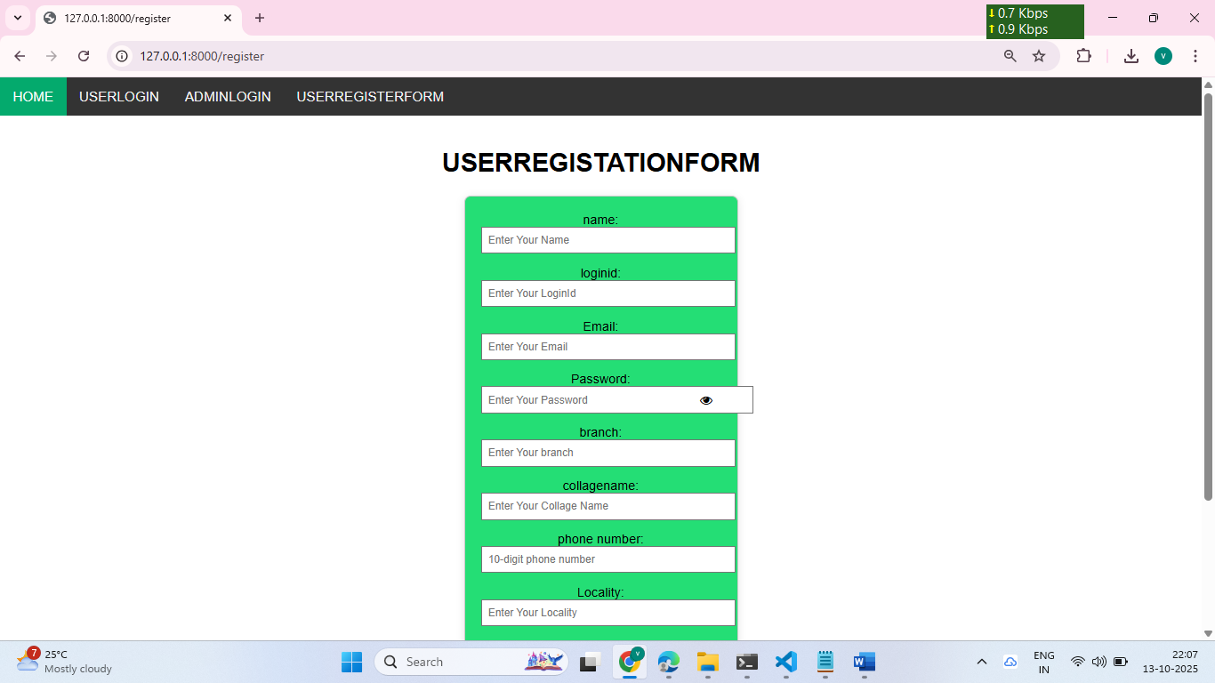

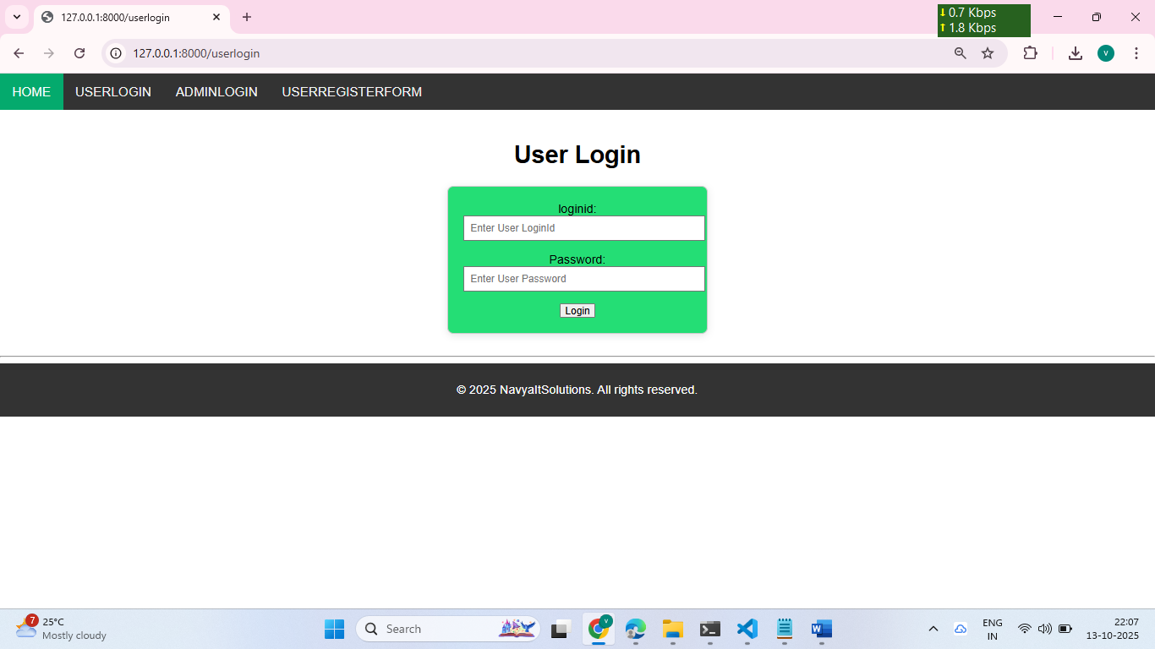

dataset based on our Django application. User can click the Classification in the web page so that the data calculated Accuracy and macro avg and weighted avg based on the algorithms. User can display the algorithm and prediction results. After that user can logout.

**Admin:**

Admin can login with his login details. Admin can activate the registered users. Once he activate then only the user can login into our system. Admin can view the overall data in the browser. Admin can click the Results in the web page so calculated Accuracy and macro avg and weighted avg based on the algorithms. All algorithms execution complete then admin can see the overall accuracy in web page. After that admin can logout.

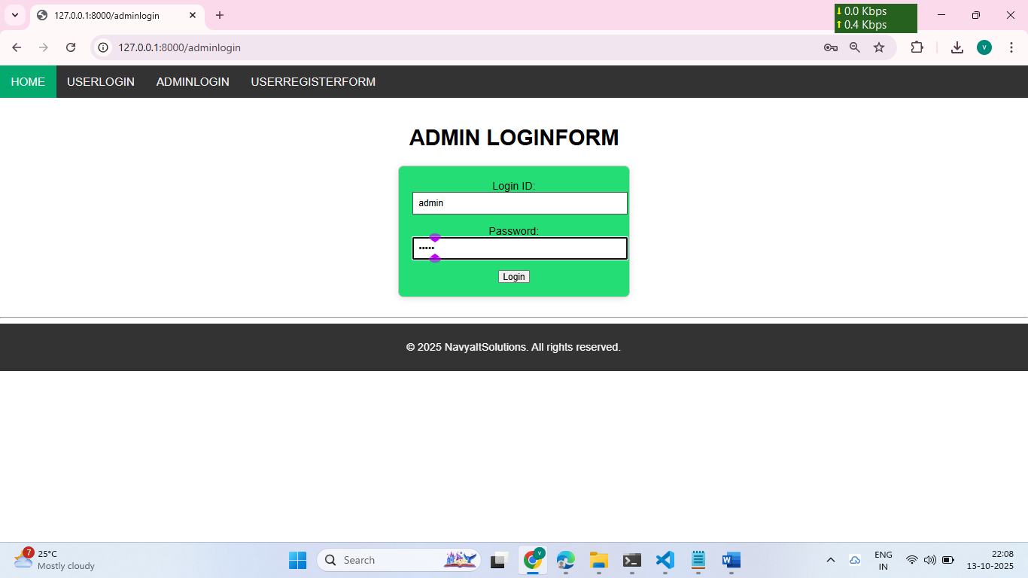

**Income classification:**

The Adult Income Prediction system aims to classify whether an individual earns more than $50K or less than or equal to $50K per year based on their demographic and employment attributes. The dataset contains features such as age, education, occupation, hours worked per week, and marital status.  
By applying machine learning algorithms, this model predicts income levels, helping organizations and researchers understand the key factors affecting income distribution. The system mainly uses the Random Forest Classifier, which provides high accuracy and handles large datasets efficiently.

Machine learning:

Moreover, image processing technology in the classification types of rice leaf disease, such as; Random Forest classification algorithm, Decision tree classification algorithm, Gradient Boosting classification algorithm and Naive-Baye classification algorithm, which is measured by the accuracy, precision and recall of each algorithm. The best result of performance in the image classification of rice leaf diseases is random forest algorithm equal to 69.44 percent.

**Data Collection & Preparation**

ML depends heavily on data. It is the most crucial aspect that makes algorithm training possible. So, this section allows you to download the required dataset.

**Collect the Dataset**

There are many popular open sources for collecting the data. Eg: kaggle.com, UCI repository, etc.  In this project we have used .csv data. This data is downloaded from kaggle.com. Please refer to the link given below to download the dataset.

Dataset: [LINK](https://www.kaggle.com/datasets/lovishbansal123/adult-census-income/data)

 Importing the libraries

Import the necessary libraries as shown in the image.

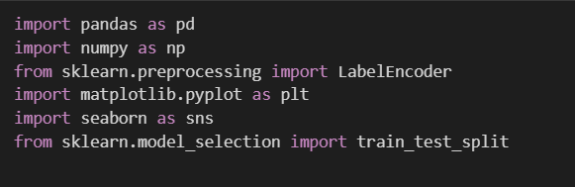

**Read the Data set**

Our dataset format might be in .csv, excel files, .txt,.json, etc. We can read the dataset with the help of pandas. In pandas, we have a function called read_csv() to read the dataset. As a parameter, we have to give the directory of the csv file.

**Raw data set**

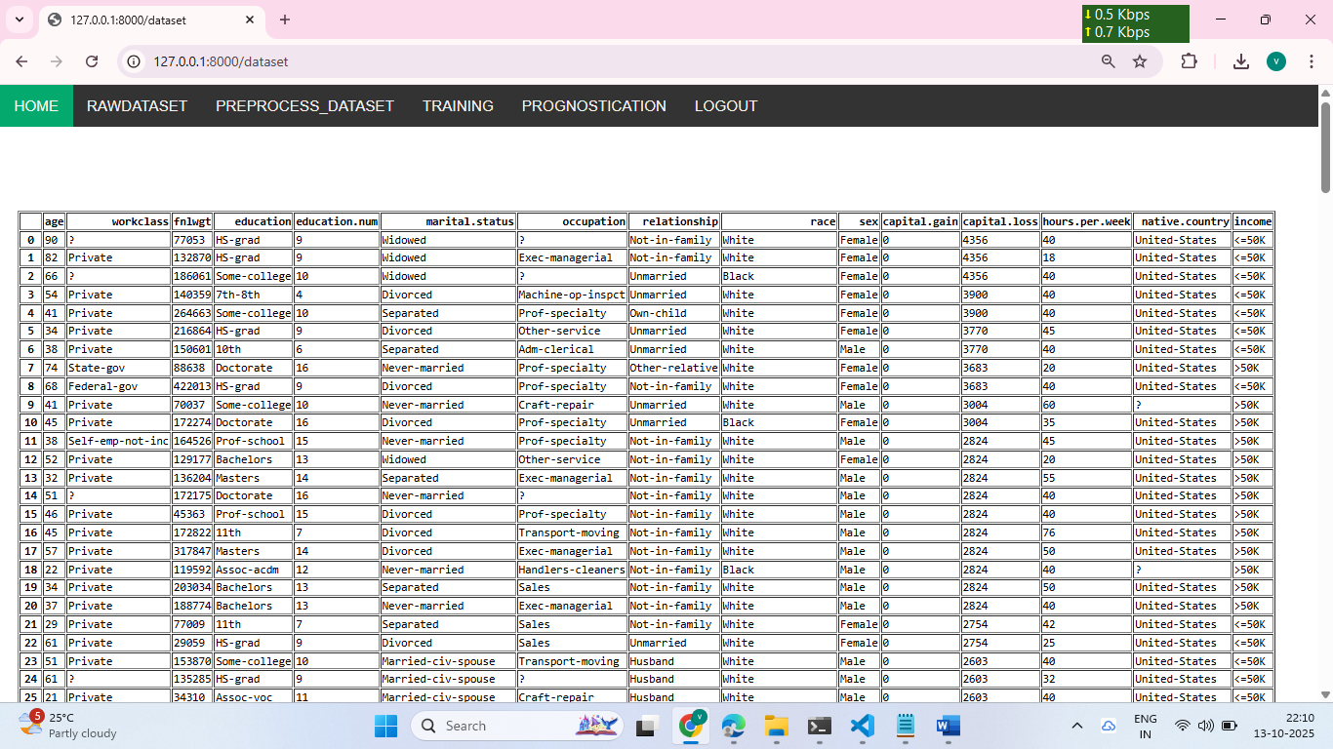

**Data Preparation**

As we have understood how the data is, let's pre-process the collected data.

The download data set is not suitable for training the machine learning model as it might have so much randomness and noise. So we need to clean the dataset properly in order to fetch good results.

This activity includes the following steps.

* Handling missing values
* Handling categorical data
* Handling Outliers

1.Handling Missing Values

Let’s find the shape of our dataset first. To find the shape of our data, the df. shape method is used. To find the data type, df.info () function is used.

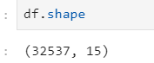

Above Figure Describes the Shape of the Dataset i.e, there are 32537 rows and 15 columns including the Target column as well.

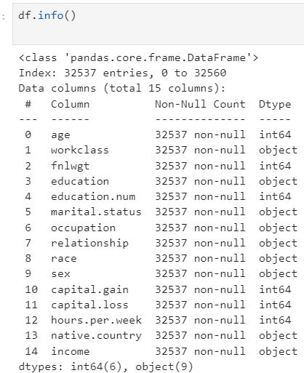

  df.info() provides the information about the column’s datatype and provides the count of non-null values in the column.

Dataset do not have any missing values.

For checking the null values, df.isnull() function is used. To sum those null values, we use .sum() function. From the below image, we found that there are no null values present in our dataset:

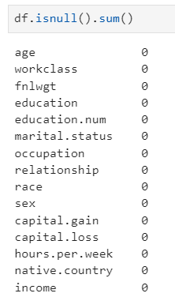

From the above figure, we can observe that there are no null values present in the dataset.

2. Handling Categorical Values:

There are multiple categorical columns present in the dataset, they are Work class, Sex, Race, Education, Occupation, Relationship, Marital Status and native country.

As we know there are no missing values/ null values present in the dataset. We need to know the number of categories present in each column with their counts.

There are several operations to find different insights using categorical values some of the functions are value_counts, cross_tab(), mode, and replacement of values.

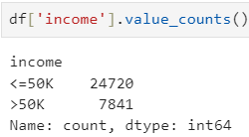 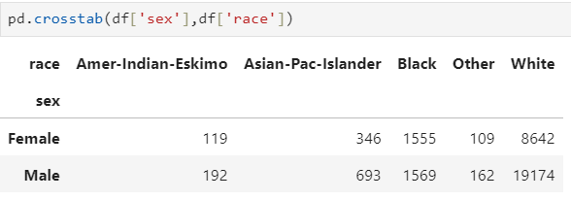

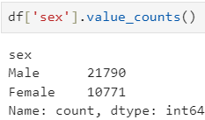

  There are a few unknown values in the occupation and Work class columns represented in “?”  so we need to treat them by replacing them with the general category as “Others”.

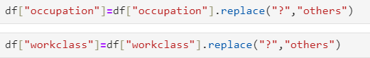

At last, we have all the values regarding the categorical column. For the further process of model building, we have to encode the categorical values with numerical values. We have used label encoding. The process of label encoding can be obtained from the below snippet of code.

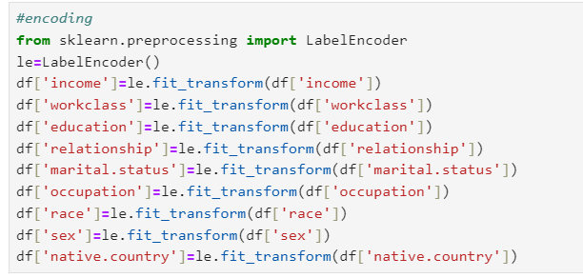

**Treating Outliers:**

Outliers are the abnormal data that are away from the range of the distribution of the data of each column in the data. Here we have the box plot to find whether the Outliers are present or not

but we cannot know how many Outliers are present in the Age column.

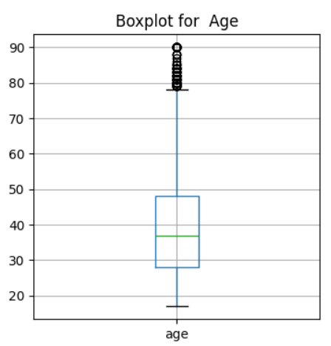

Actually we are preparing the model for the Adult's income so adults' age ranges from 20 to 90 but we must not consider the person whose age is 90 is not an outlier even though we need not change or modify the Age column. It is observed that there is no data present below the lower limit of the data.

**Descriptive Analysis**

Descriptive analysis involves examining fundamental characteristics of data using statistical methods. It provides insights into the mean, standard deviation, minimum, maximum, and percentile values of continuous features.

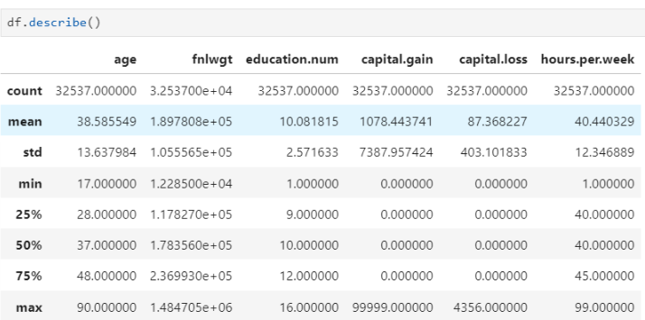

**1.Visual analysis**

Visual analysis is the process of using visual representations, such as charts, plots, and graphs, to explore and understand data. It is a way to quickly identify patterns, trends, and outliers in the data, which can help to gain insights and make informed decisions.

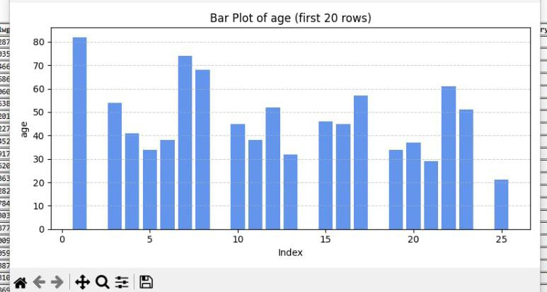

Age Distribution ranges from 15 to 65years

The histogram describes the distribution of Age in the dataset and a KDE plot is being added to find skewness of the age and range of distribution of ages.

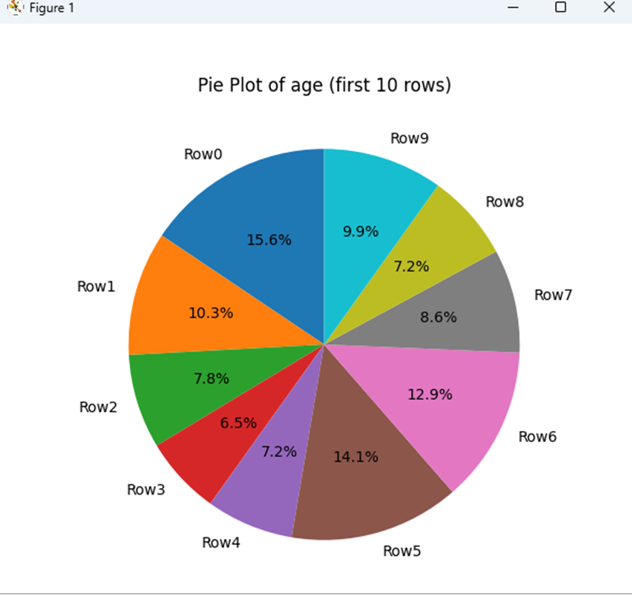

In simple words, univariate analysis is understanding the data with a single feature. Here we have displayed a histogram, Pie chart, and Horizontal bar plot.

**2. Bivariate analysis**

Bivariate analysis is a statistical method that involves the analysis of two variables to determine the empirical relationship between them. Here we have grouped bar plots and horizontally grouped Bar charts.

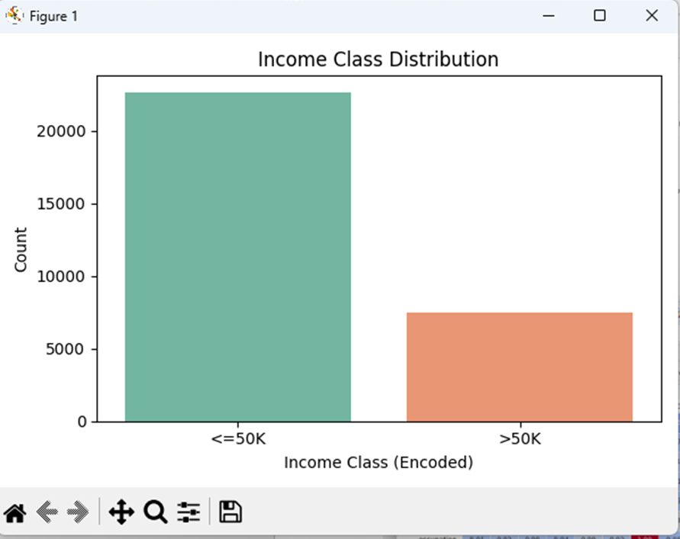

**3.Balancing data**

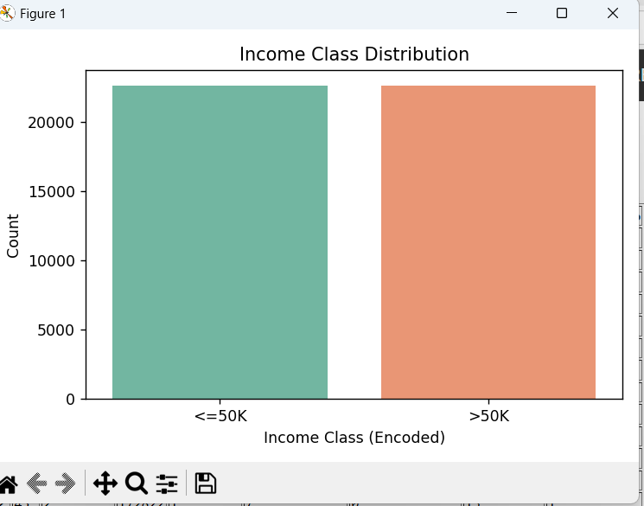

Data is imbalanced since the category for the target category column counts having a major difference between the categories so we need to make the data balanced so we use SMOTE technique to balance the data.

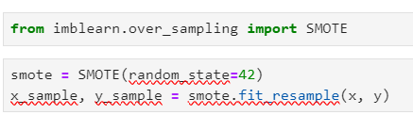

**Splitting data into train and test**

Now let’s split the Dataset into train and test sets. First, split the dataset into x and y and then split the data set. “x” represents the whole data columns other than the target column” represents the Target column in the dataset. We need to build the model by giving the training to the model and making the predictions on the test data.so we need to divide the whole dataset into training and testing data.

For splitting training and testing data we are using train_ test_ split () function from Sklenar. As parameters, we are passing x, y, test size, random state.

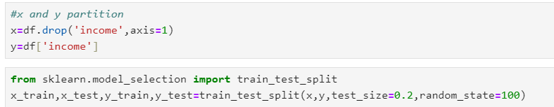

**Performance Testing**

Under performance Testing we need to test the model’s accuracy with different testing Metrics like Precision, Recall and F1_score. Below are the performance Metrics of final fixed model

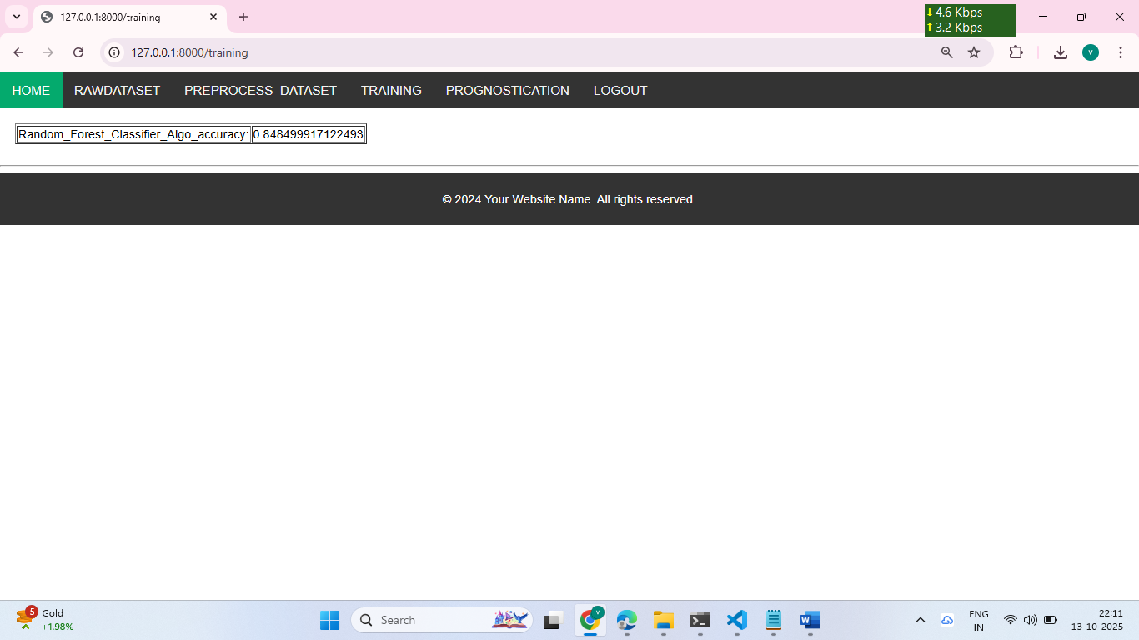

**5.Multi-variate analysis**

variate analysis is a statistical method that involves the analysis of more than 2 variables to determine the empirical relationship among them. Here we have a heatmap representing the correlation among the variables in the Data.

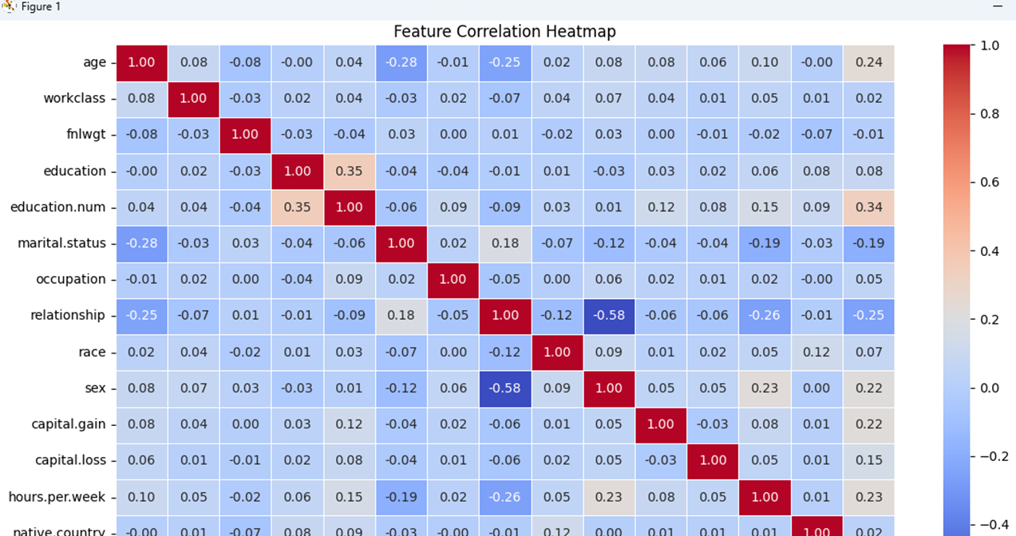

**Performance Testing**

Under performance Testing we need to test the model’s accuracy with different testing Metrics like Precision, Recall and F1_score. Below are the performance Metrics of final fixed model

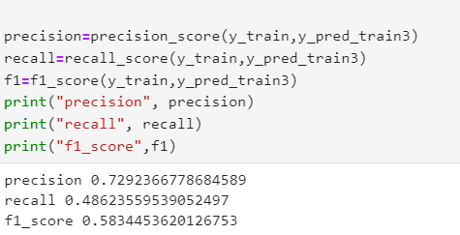

**Test the model**

Let’s test the model first in python notebook itself. As we have 7 features in this model, let’s check the output by giving all the inputs.

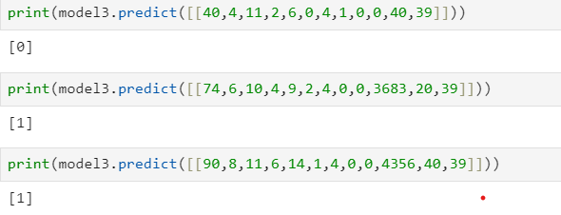

The predicted value and actual value are results same.

**Project Structure**

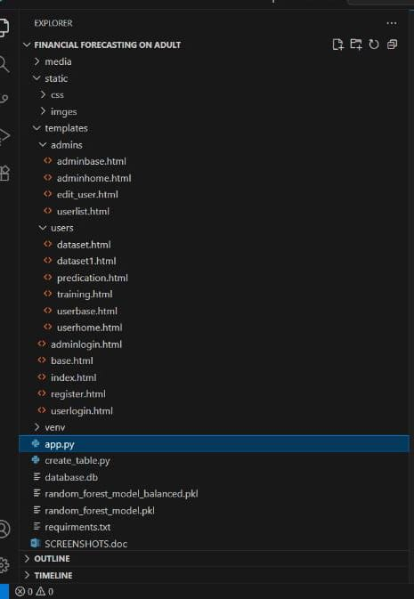

1. We are building a Flask application that needs HTML pages stored in the Template folder and python script app.py for scripting
2. dtree.joblib is our saved model. Further, we will use this model for flask integration.
3. Training folder contains a model training file.

INPUT AND OUTPUT DESIGN

INPUT DESIGN

The input design is the link between the information system and the user. It comprises the developing specification and procedures for data preparation and those steps are necessary to put transaction data in to a usable form for processing can be achieved by inspecting the computer to read data from a written or printed document or it can occur by having people keying the data directly into the system. The design of input focuses on controlling the amount of input required, controlling the errors, avoiding delay, avoiding extra steps and keeping the process simple. The input is designed in such a way so that it provides security and ease of use with retaining the privacy. Input Design considered the following things:

* What data should be given as input?
* How the data should be arranged or coded?
* The dialog to guide the operating personnel in providing input.
* Methods for preparing input validations and steps to follow when error occur.

OBJECTIVES

1.Input Design is the process of converting a user-oriented description of the input into a computer-based system. This design is important to avoid errors in the data input process and show the correct direction to the management for getting correct information from the computerized system.

2. It is achieved by creating user-friendly screens for the data entry to handle large volume of data. The goal of designing input is to make data entry easier and to be free from errors. The data entry screen is designed in such a way that all the data manipulates can be performed. It also provides record viewing facilities.

3.When the data is entered it will check for its validity. Data can be entered with the help of screens. Appropriate messages are provided as when needed so that the user will not be in maize of instant. Thus, the objective of input design is to create an input layout that is easy to follow

OUTPUT DESIGN

A quality output is one, which meets the requirements of the end user and presents the information clearly. In any system results of processing are communicated to the users and to other system through outputs. In output design it is determined how the information is to be displaced for immediate need and also the hard copy output. It is the most important and direct source information to the user. Efficient and intelligent output design improves the system’s relationship to help user decision-making.

1. Designing computer output should proceed in an organized, well thought out manner; the right output must be developed while ensuring that each output element is designed so that people will find the system can use easily and effectively. When analysis design computer output, they should Identify the specific output that is needed to meet the requirements.

2.Select methods for presenting information.

3.Create document, report, or other formats that contain information produced by the system.

The output form of an information system should accomplish one or more of the following objectives

* Convey information about past activities, current status or projections of the
* Future.
* Signal important events, opportunities, problems, or warnings.
* Trigger an action.
* Confirm an action.

**Integrate with Web Framework**

In this section, we will be building a web application that is integrated to the model we built. A UI is provided for the uses where he has to enter the values for predictions. The enter values are given to the saved model and prediction is showcased on the UI.

This section has the following tasks

* Building HTML Pages
* Building server-side script
* Run the web application

1. Building Html Pages:

For this project create two HTML files namely

* index.html
* predict.html
* result.html

and save them in the templates folder.

2: Build Python code:

Import the libraries

  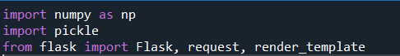

 Load the saved model. Importing the flask module in the project is mandatory. An object of Flask class is our WSGI application. Flask constructor takes the name of the current module (__name__) as argument.

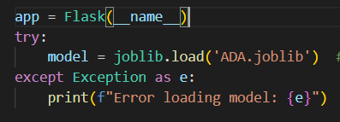

We render index.html for the displaying the web application , similarly we render the predict.html for the user input values of the forms to predict the income. Simultaneously we render result .html to display the result of the prediction value.

Render Index.html:

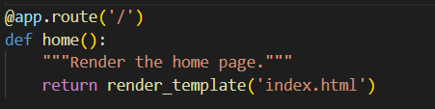

Here we will be using a declared constructor to route to the HTML page which we have created earlier.

 In the above example, ‘/’ URL is bound with the index.html function. Hence, when the home page of the web server is opened in the browser, the html page will be rendered.

Render Predict.html:

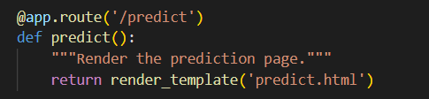

In the predict.html where we provide the user inputs in the form for the prediction of income

Whenever you enter the values from the html page the values can be retrieved using POST and GET Methods.

Retrieving the value from UI:

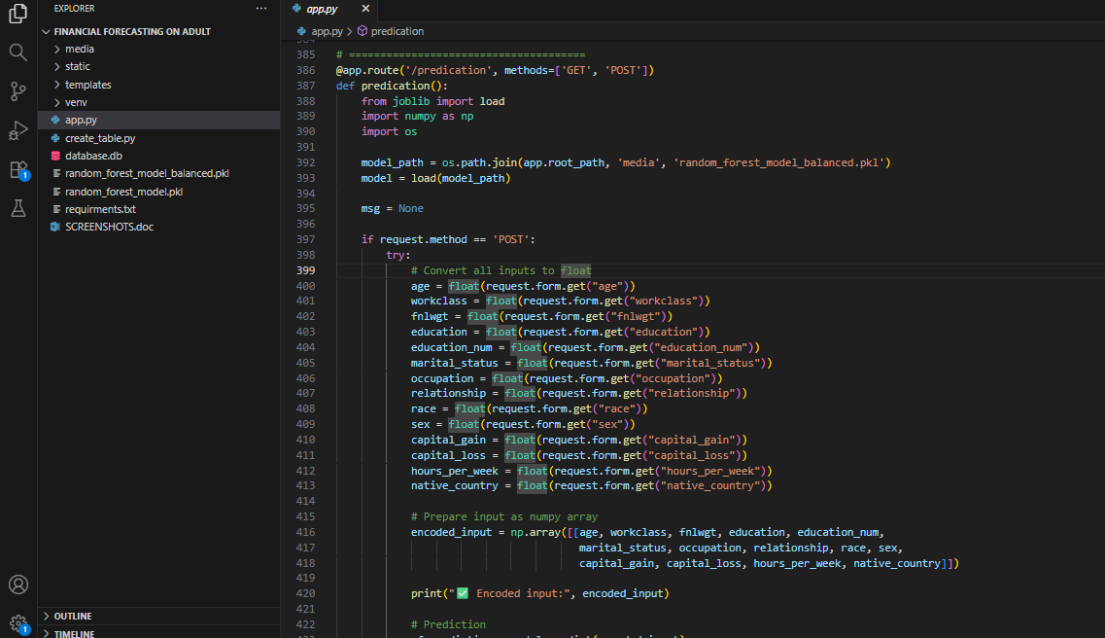

Here we are routing our app to conditional statement. This will retrieve all the values from the HTML page using Post request. That is stored in an array. This array is passed to the model.predict() function. This function returns the prediction. And this prediction value will be rendered to the text that we have mentioned in the submit.html page earlier.

Main Function:

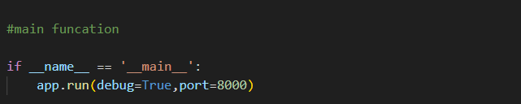

Run the web application

* Open vs code application in the search menu.
* Navigate to the folder where your flask folder of your files exist.
* Click on the view button in the vs code nav bar and click on the terminal option in the dropdown menu.
* Now type “app.py” command
* You will have a link displayed in the terminal as “http://127.0.0.1:8000”
* Double clicks on the link then you will be navigated to the web application.
* Click on the predict button in the nav bar , enter the inputs, click on the predict button, and see the result/prediction in the result.html.

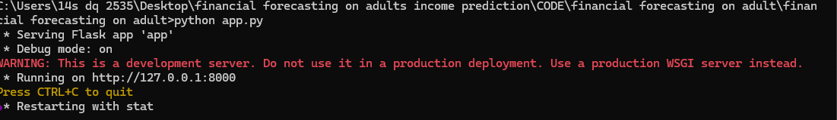

     Now, Go the web browser and write the localhost URL (http://127.0.0.1:4000) to get the below results

Results:

WEBSITE HOMEPAGE:





If you click on the predict on the nav bar we can able to navigate to predict.html below figure represents the UI of predict.html page

1. Prediction page (Predict.html)

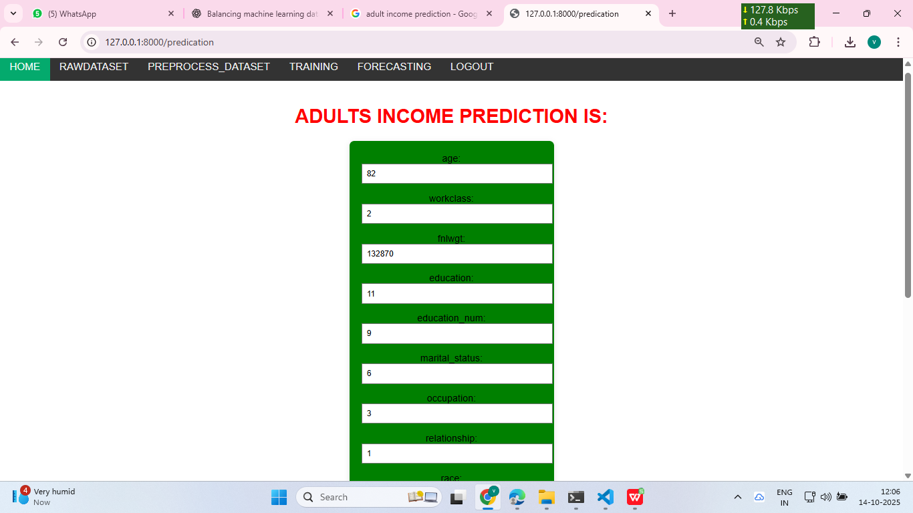 By providing the inputs by the user and click on the predict button you will be navigating to the result.html it displays the result. Based on the result you can navigate to the home and click on the investments in the nav bar of index.html then you can have an info about different mode of investments.

Result.html:

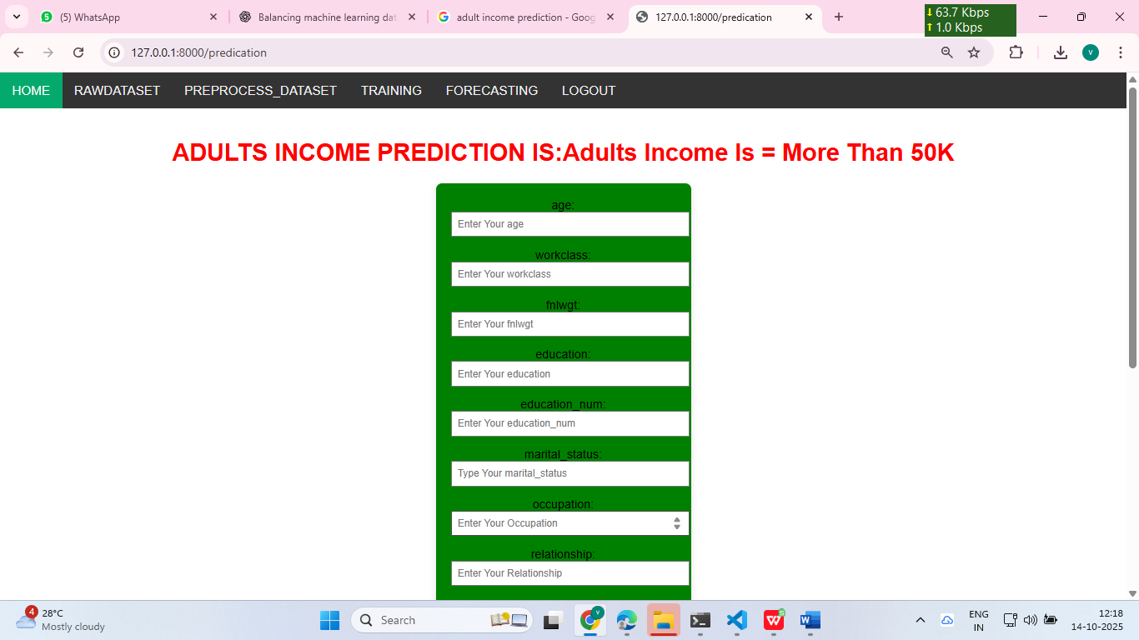

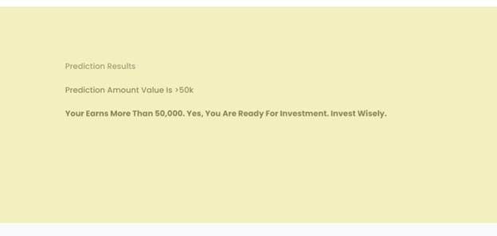

**Future Enhancement**

Although the current system performs well, there is still scope for further improvement and expansion. In the future, the following enhancements can be implemented:

1. Integration of Deep Learning Models: Advanced algorithms such as Neural Networks or Gradient Boosting methods (e.g., XG Boost or Light(GBM) can be explored to achieve higher accuracy and better generalization.
2. Real-Time Prediction System: The model can be deployed as a real-time web or mobile application, allowing users to make instant predictions through a user-friendly interface.
3. Automated Feature Selection: Implementing automated feature engineering and dimensionality reduction techniques (like PCA) can further improve performance.
4. Model Optimization: Hyperparameter tuning and ensemble stacking can be applied to enhance the accuracy and reduce computation time.
5. Continuous Learning: The system can be upgraded to learn from new data dynamically, ensuring that predictions remain accurate and up to date.

**Bibliography**

1. Pedregosa, F., Varoquaux, G., Gram fort, A., Michel, V., Thirion, B., Grisel, O., ... & Vanderplas, J. (2011). Scikit-learn: Machine learning in Python. Journal of Machine Learning Research, 12(Oct), 2825-2830.

2. Chen, T., & Guestrin, C. (2016). XG Boost: A scalable tree boosting system. In Proceedings of the 22nd ACM SIGKDD International Conference on Knowledge Discovery and Data Mining (pp. 785-794).

3. Breiman, L. (2001). Random forests. Machine learning, 45(1), 5-32.

4. Hastie, T., Tibshirani, R., & Friedman, J. (2009). The elements of statistical learning: data mining, inference, and prediction. Springer Science & Business Media.

5. Zhang, Q., & Wallace, B. (2019). A survey on transfer learning. IEEE Transactions on Knowledge and Data Engineering, 28(10), 2736-2753.

6. Goodfellow, I., Bengio, Y., & Courville, A. (2016). Deep learning. MIT press.

7. Chollet, F. (2017). Deep learning with Python. Manning Publications.

8. Zou, H., & Hastie, T. (2005). Regularization and variable selection via the elastic net. Journal of the Royal Statistical Society: Series B (Statistical Methodology), 67(2), 301-320.

9. Lipton, Z. C., Steinhardt, J., & Elkan, C. (2018). Troubling trends in machine learning scholarship. arXiv preprint arXiv:1807.03341.

10. Gebru, T., Morgenstern, J., Vecchione, B., Vaughan, J. W., Wallach, H., Daumé III, H., & Crawford, K. (2018). Datasheets for datasets. arXiv preprint arXiv:1803.09010.

11. Ras, Z. W. (2003). Feature selection with neural networks: A survey. Neural Computation, 13(11), 2509-2531.

12. Dua, D., & Graff, C. (2017). UCI Machine Learning Repository. University of California, Irvine, School of Information and Computer Sciences. [http://archive.ics.uci.edu/ml]

**Prior Knowledge**

You must have the prior knowledge of the following topics to complete this project.

* ML Concepts:
* Supervised learning: [https://www.javatpoint.com/supervised-machine-learning](http://www.javatpoint.com/supervised-machine-learning)
* Logistic Regression: https://www.geeksforgeeks.org/understanding-logistic-regression/
* Gradient boosting regressor: https://www.geeksforgeeks.org/ml-gradient-boosting/
* Decision Tree Classifier: https://www.geeksforgeeks.org/decision-tree/
* Flask Basics: [https://www.youtube.com/watch?v=lj4I_CvBnt0](http://www.youtube.com/watch?v=lj4I_CvBnt0)

**CONCLUSION**

In this comprehensive analysis of adult census income prediction using machine learning techniques, we explored various algorithms and methodologies to build predictive models. Through meticulous data preprocessing, feature engineering, and model evaluation, we aimed to develop accurate and robust models capable of discerning individuals' income levels based on demographic, educational, and occupational attributes. The project commenced with a clear problem statement: predicting whether an individual earns more than $50,000 per year, framing it as a binary classification task. We explored a traditional machine learning workflow, encompassing key steps such as data exploration, data cleaning, feature engineering, model building, and model testing. Future Forecast: Based on this data, it estimates what the future income of this new person might be. the company decides whether it is safe to give a loan to that person.